**Logic gates (1)**

**Name class**

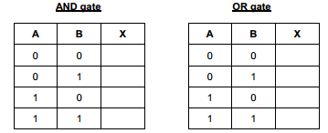1.(a) Two logic gates are the AND gate and the OR gate. Complete the truth tables for these two gates:

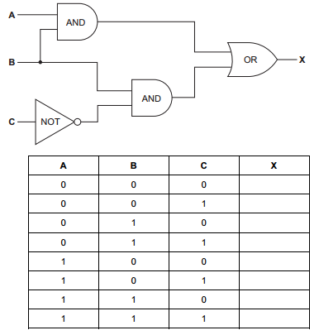(b) Complete the truth table for the following logic circuit:

1. finish the truth table of the following logic circuit

(i)

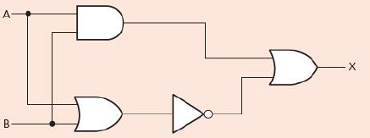

|  |  |  |
| --- | --- | --- |
| A | B | X |
|  |  |  |
|  |  |  |
|  |  |  |
|  |  |  |

1. Complete the truth table for the following logic circuit

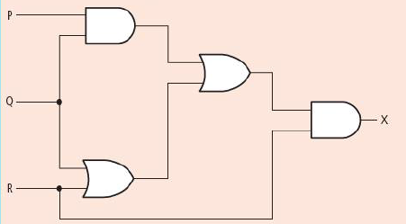

|  |  |  |  |
| --- | --- | --- | --- |
| P | Q | R | X |
|  |  |  |  |
|  |  |  |  |
|  |  |  |  |
|  |  |  |  |
|  |  |  |  |
|  |  |  |  |
|  |  |  |  |
|  |  |  |  |